FremantleMedia Italia and Rai Cinema presentano

Isis, tomorrow. The lost souls of Mosul

a documentary by di Francesca Mannocchi and Alessio Romenzi
Produced by FremantleMedia Italia and Rai Cinema
In collaboration with Bayerischer Rundfunk and arte

In coproduction with Wildside and Cala Film Filmproduktion

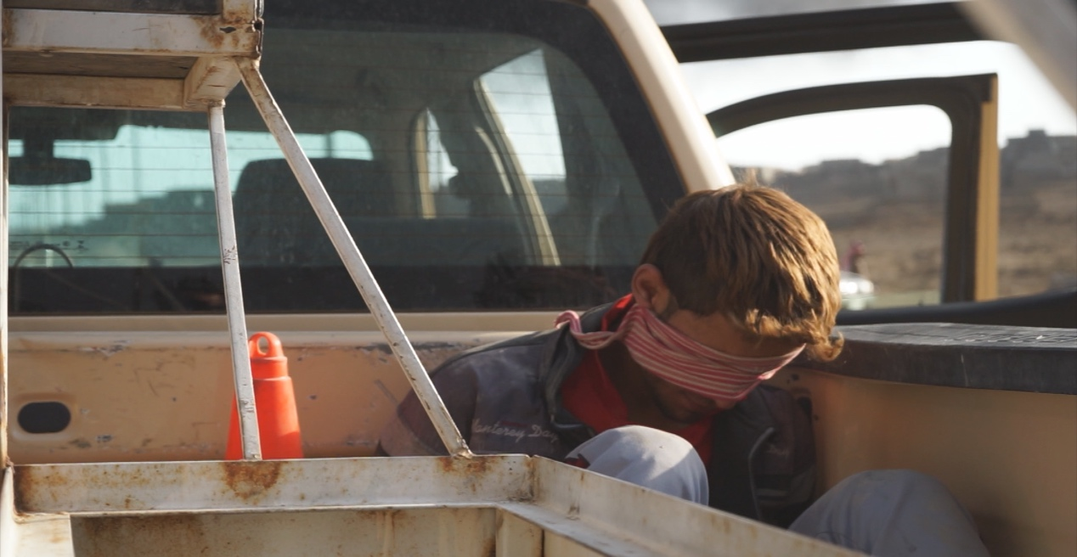
Synopsis
Isis, tomorrow. The lost souls of Mosul

Production year: 2018
Countrie: Italia, Germania

Lenght: 80’
Language: Iraqui arab subt. ITA/ENG

In wars it is not uncommon for the defeated to bury their weapons before retreating, hiding arsenals waiting for better times. The weapons that Isis has left in inheritance for the future are hundreds of thousands of children educated in violence and martyrdom. In Isis’s ideology children are the most effective weapon to bring into the future the idea of a great universal Caliphate: successors of one goal, creating a world divided in half, on the one the Jihadists and on the other the infidels to be exterminated.
After the war, will Iraq be able to accept Isis’s children as its own children, forgive their mothers, and reconcile the souls of the country?
Isis, Tomorrow traces the months of war through the voices of the children of militiamen trained to become suicide bombers, but also of their victims and those who fought them. Today, fighters’ descendants are children who bear the burden of having been educated to kill their neighbours and to make the ideology survive so that it can be reborn from the ashes of the fathers.
Isis, Tomorrow follows the destiny of the surviving families of the fighters in the complexity of the post-war period, a post-war time of marginalization and stigma, in which battle blood leaves room for daily revenge and retaliation, for violence as the only response to violence.
The future of Iraq is at stake with the destiny of these children - the children of the executioners - their salvation and the forgiveness that will be granted or denied to them by the children of the victims, and, at the same time, the future of a terrorist movement that might regenerate from the same roots that gave rise to it years ago.
500 thousand minors lived in Mosul alone, during the three years of occupation of the Islamic State.

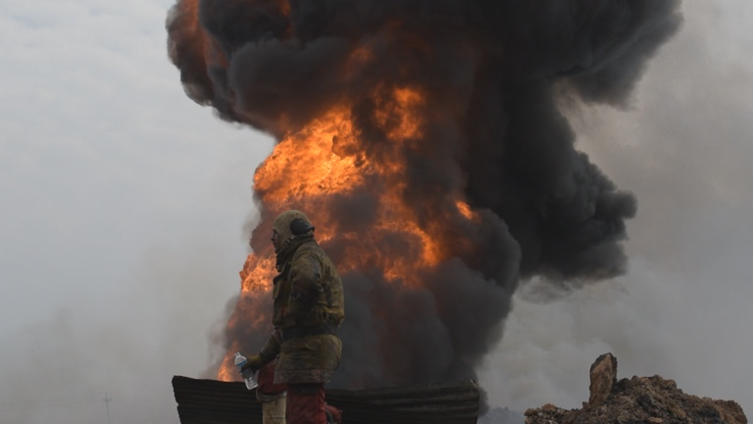
Directors notes

Isis, tomorrow.
The lost souls of Mosul

Isis has lost Mosul. But has it been really defeated?
Or does real war - for those who have endured it and those who survive – begin right the day after a proclaimed victory?
This film stems from the questions which became more and more insistent every day of the months of fighting in Mosul and which accompanied us in the strenuous phases of the post-war period: what is necessary to do to save the hundreds of thousands of children raised for three years under Isis? How can we prevent these children from being the breeding ground for tomorrow’s terrorism?
We have chosen to listen to the widows, daughters and sons of the perpetrators in order to try to understand this.

Biographies

FRANCESCA MANNOCCHI  October 1, 1981, freelance reporter, and director.  Francesca Mannocchi has worked for a number of Italian and international newspapers and TV channels for several years. She mainly engages in the narrative of migrations and conflict zones. She has produced news reports from Iraq, Libya, Lebanon, Syria, Tunisia, Egypt, and Afghanistan. She followed and told about the difficult post-revolutionary transition in Libya, the wars in Gaza, the coup in Egypt in 2013, the fighting to free Sirte and Mosul from Isis occupation. She has been honored with two prizes: Premio Giustolisi for her survey on the smuggling of migrants and Libyan prisons, and 2016 Premiolino, the main prize for journalists in Italy.  January will see the release of her first book: Everyone Shall Take Their Own Blame, Laterza Publishing Company | ALESSIO ROMENZI  April 30, 1974, photographer.  Alessio Romenzi’s photos are on the pages of prime international newspapers: Time Magazine, International Herald Tribune, Los Angeles Times, Newsweek, L'Espresso, Der Spiegel, Paris Match, and Stern. His work focuses on wars and migratory phenomena.  He depicted the Arab Springs before devoting himself to the Syrian conflict.He was one of the first photographers who could document the protests against Bashar al Assad’s regime and then the war in Syria. Recently he focused on the migratory phenomenon in Libya and to the fighting to free Sirte and Mosul from Isis occupation.  He has been honored with the World Press Photo and many other international awards including Picture of the Year, Premio Baldoni, Premio Dolega.  Year, Premio Baldoni, Premio Dolega.

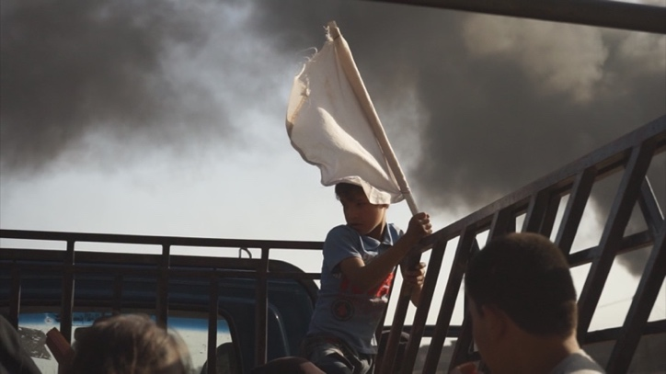
Credits
Isis, tomorrow. The lost souls of Mosul
Ita 2018, 80’, arabo iracheno sott. ita

Written and directed | Francesca Mannocchi  Alessio Romenzi
Directors of photography | Francesca Mannocchi Alessio Romenzi
Edited by | Emanuele Svezia  Sara Zavarise
Original Music | Andrea Ciccarelli
Graphic Design | Stax
Produced by | Fremantle Media Italia con Rai Cinema  In collaborazione con Bayerischer Rundfunk con arte
In co – production with | Wildside e Cala Filmproduktion
Produced By | Lorenzo Gangarossa Gabriele Immirzi
Executive Producer | Silvia Bonanni
Associate Producer | Martina Veltroni
Co-Producer | Martina Haubrich
World sales | CINEPHIL  Philippa Kowarsky,  Olivier Tournaud
Production Assistant | Marta Salandi
Editor Assistant | Eleonora Carbone
Post Production supervisor | Paolo Rendina
Post Production | Za Lab  D - Color
Color Correction | Federico Belati per D – Color
Mix and sound | Stefano Bari per D – Color

Filmography

FRANCESCA MANNOCCHI  Isis, Tomorrow  the lost souls of Mosul  È la sua opera prima. | ALESSIO ROMENZI  Isis, Tomorrow  the lost souls of Mosul  È la sua opera prima.

