Cinephil presents

An Ink & Pepper / Big World Cinema / Appian Way production

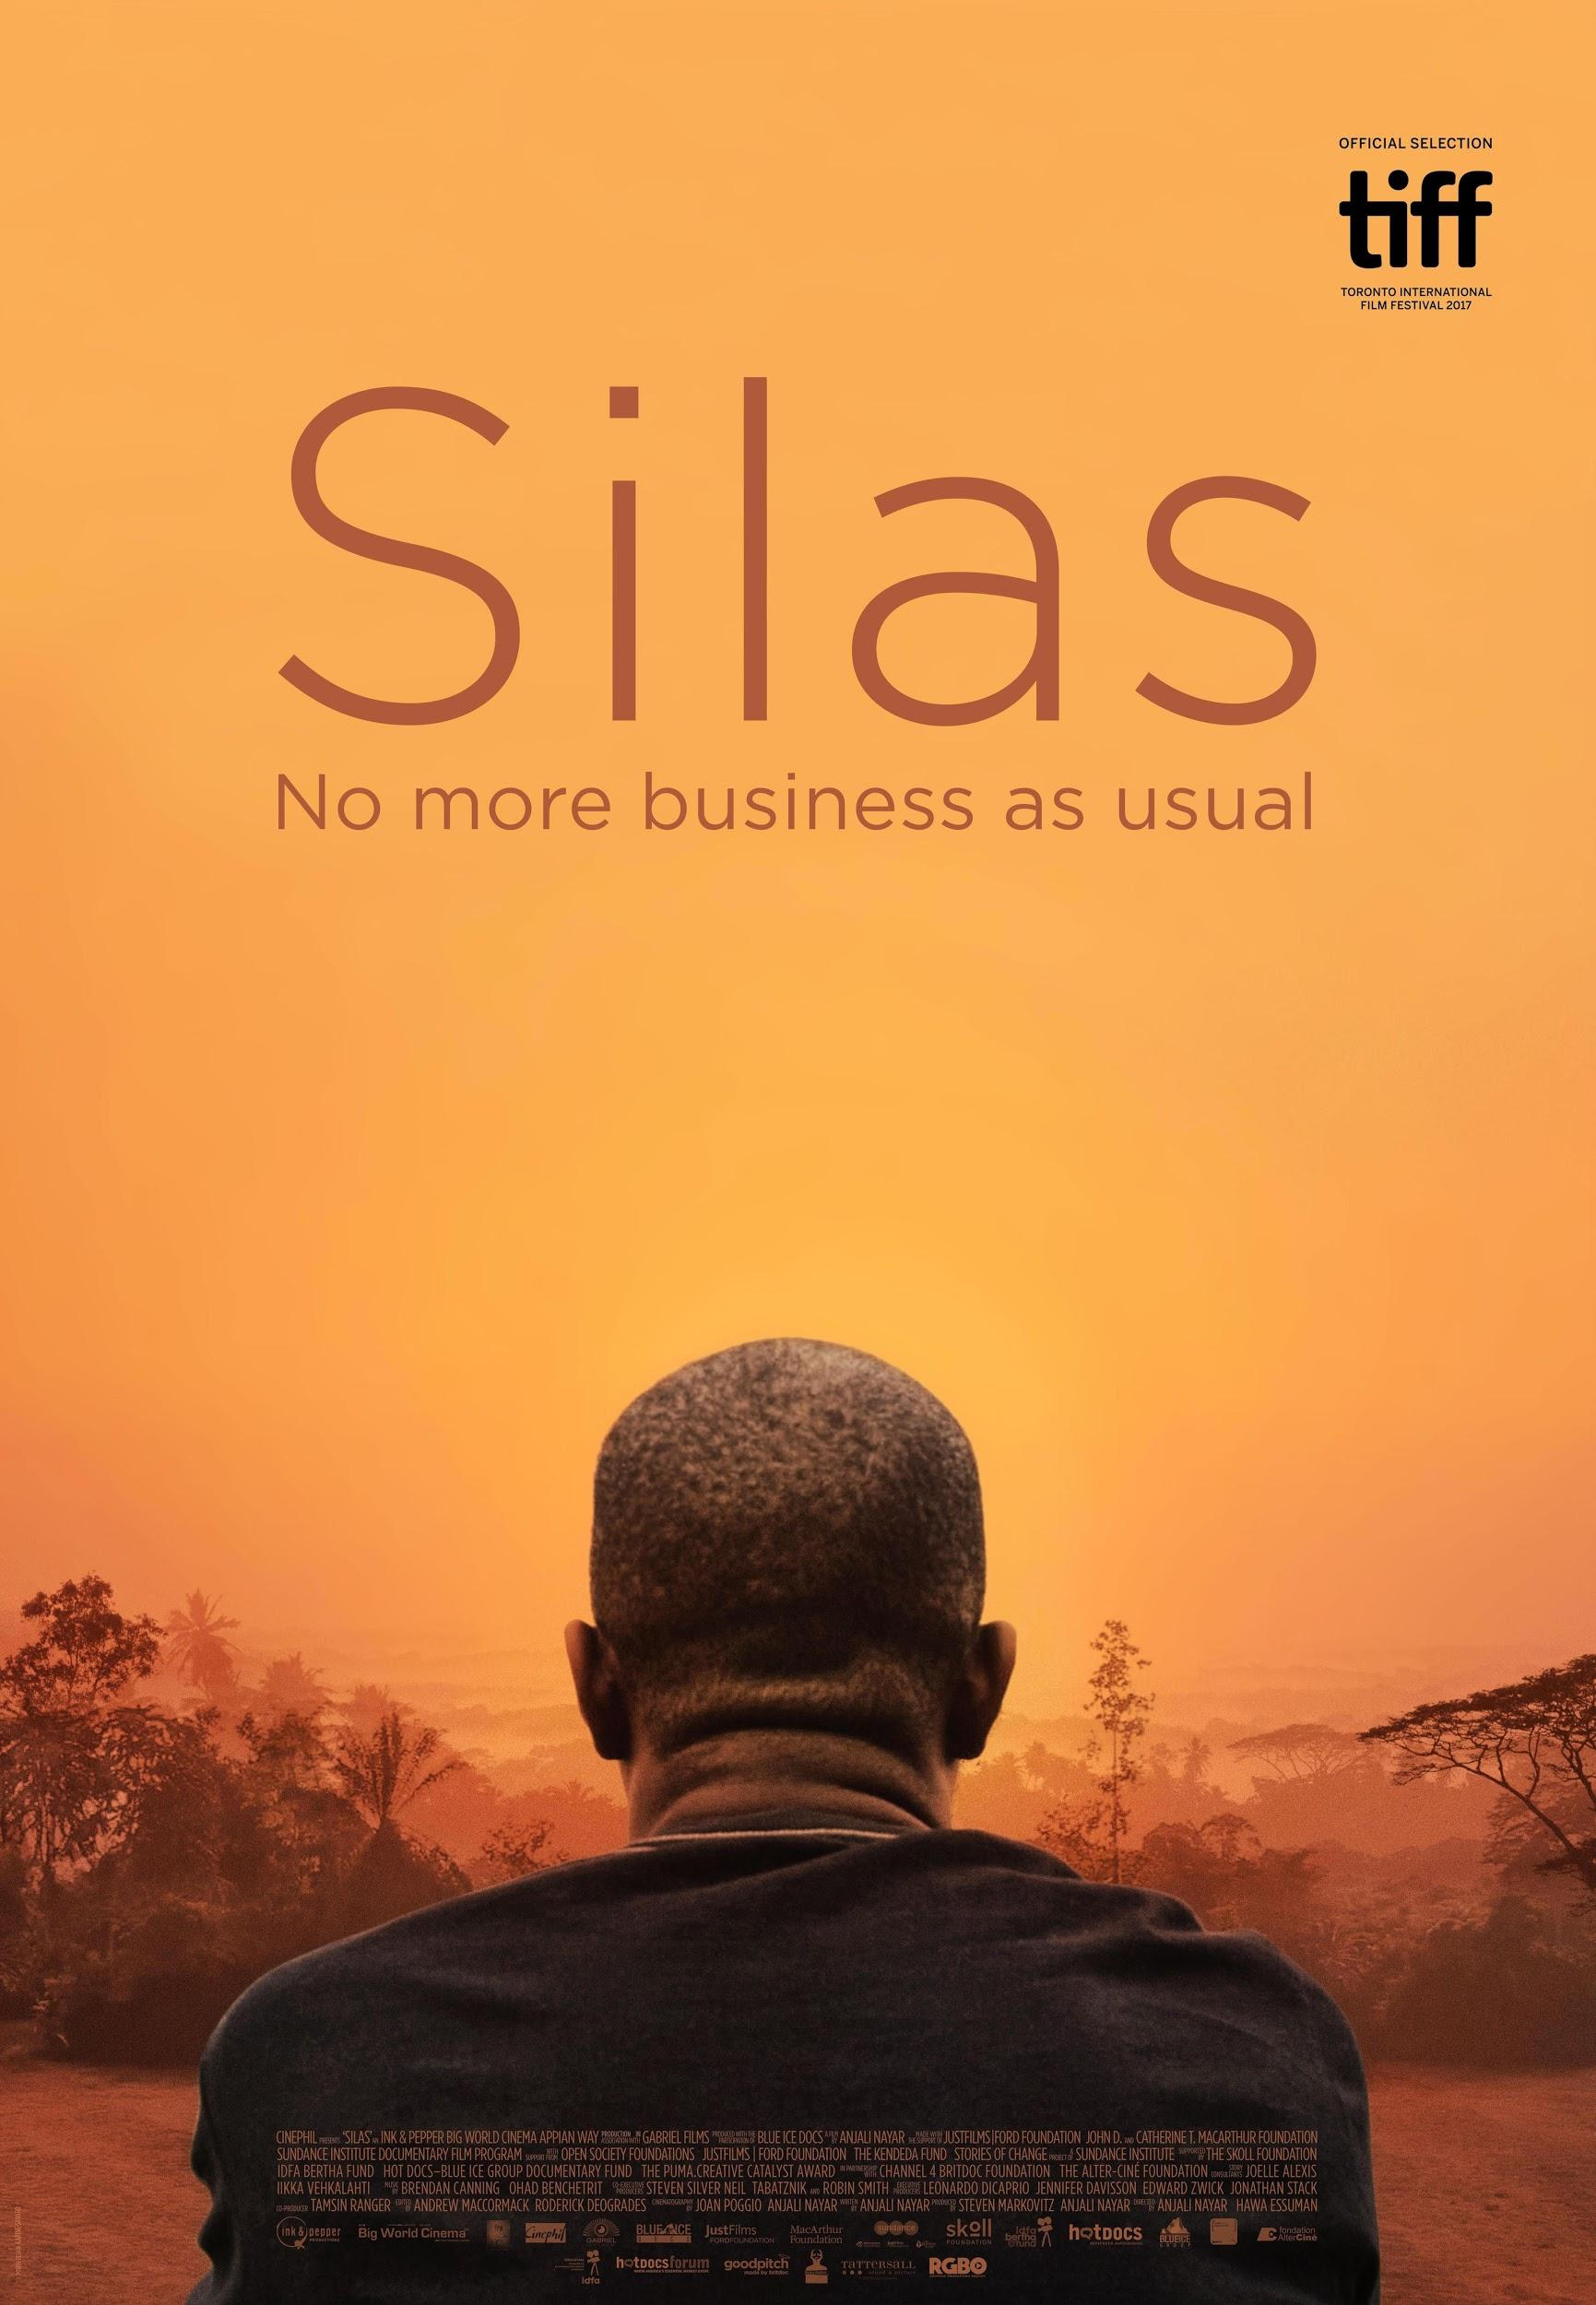
In Association with Gabriel Films
Produced with the participation of Blue Ice Docs

A film by Anjali Nayar

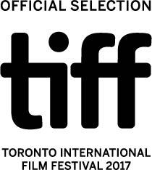

World Premiere at

80 minutes • English, Liberian English •
Canada/South Africa/Kenya • 2017

Contacts at TIFF:

Producer: Producer:
Steven Markovitz Anjali Nayar
Big World Cinema Ink & Pepper Productions
E: steven@bigworld.co.za E:
T: +27 83 2611 044 T: +1- 415-910-4625

Sales Agent: Publicist:
Philippa Kowarsky Charlene Coy
Cinephil C2C Communications
E: philippa@cinephil.com E: charlene@c2ccommunications.com
T: +972 3 566 4129 T: +1-416-451-1471

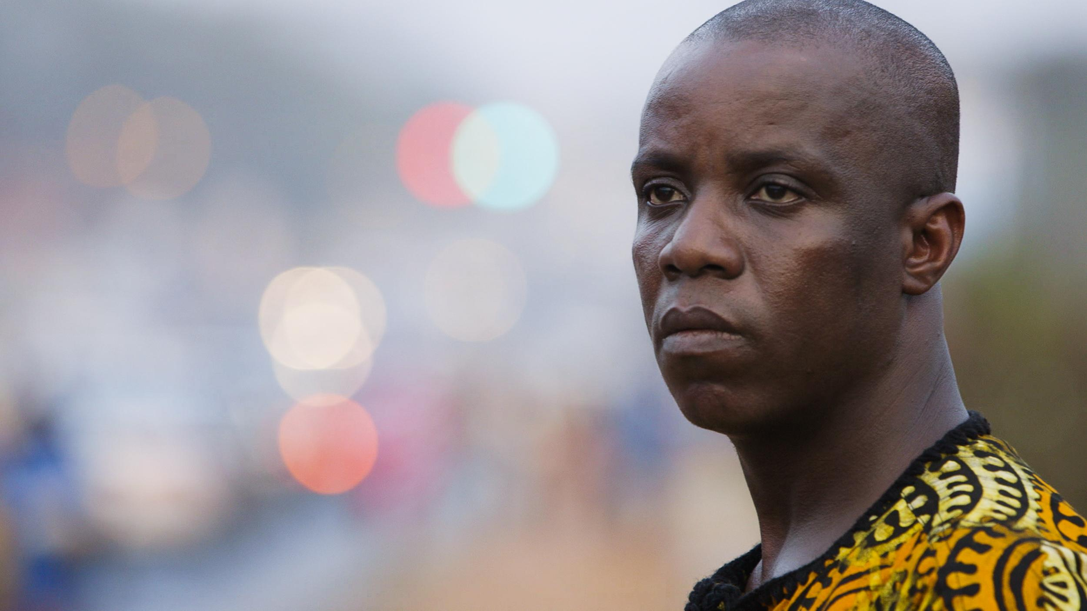

Tagline: No more business as usual

Logline
With a network of dedicated citizen reporters by his side, seasoned Liberian activist Silas Siakor challenges the corrupt and nepotistic status quo in his fight for local communities.

Synopsis

Liberian activist, Silas Siakor is a tireless crusader, fighting to crush corruption and environmental destruction in the country he loves.

Through the focus on one country, Silas is a global tale that warns of the power of politics and celebrates the power of individuals to fight back. One man's battle gains momentum and emboldens communities to raise their fists and smartphones, seize control of their lands and protect their environment. It is a new generation of resistance.

Directors’ note

Anjali had been reporting on environmental issues across the African continent for over a decade and always wondered -- how exactly does 25% of a country’s land get sold to a foreign country and why does the world only hear about it after it is too late, and communities have been stripped of their land?

One day, while writing a piece on forestry in Liberia for Nature Magazine back in 2011, Anjali called Liberian activist Silas Siakor for a quote. Despite an incredibly scratchy line from Kenya to Liberia, it was clear that Silas and his team at the Sustainable Development Institute had an incredible story to tell and could help not only us but the world to understand how we should navigate this balance between so-called “development” and environmental and social destruction.

At the time, we didn’t know where this story would lead, the twists and turns it would take and what it would mean with regards to today’s political landscape -- of powerful families and accountability in aid-dependant countries. We feel like it’s one of the most important stories of today -- how young people are stepping up, demanding accountability and taking control of the narrative of their countries.

Growing up in Kenya, Hawa’s interest in stories with emotional and political agency is rooted in the need to tell stories from a local perspective. Her desire to tell an environmental story is framed by Wangari Mathaai’s lifelong work in making sure that Nairobi’s public green spaces were kept safe by standing up to Kenyan president arap Moi.

Beyond the environment and Maathai, there are many using African-made solutions and technologies, to solve their own problems and challenges. These are stories Hawa is inspired to tell – to both challenge others to act and also to bring awareness to the serious issues facing the continent’s environment..

Biographies
Anjali Nayar - Writer/Director/Producer and TIMBY Founder
Anjali has been working with the environmental networks featured in this project for over six years. Anjali’s feature directorial debut, Gun Runners (2016), about Kenyan warriors turned marathoners, premiered at Hot Docs and is now available on Netflix. Anjali is also directing Just A Band, a fractionally-fictional documentary about an Afro-electric pop group that wants to go to space, as well as a number of short creative and virtual reality films.

Beyond film, Anjali founded TIMBY (This Is My Backyard), a suite of digital tools that helps activists report, verify and tell stories safely. She has a Masters from Columbia’s Graduate School of Journalism, a Masters in Environmental Management from Oxford and a Graduate degree from the International Space University.

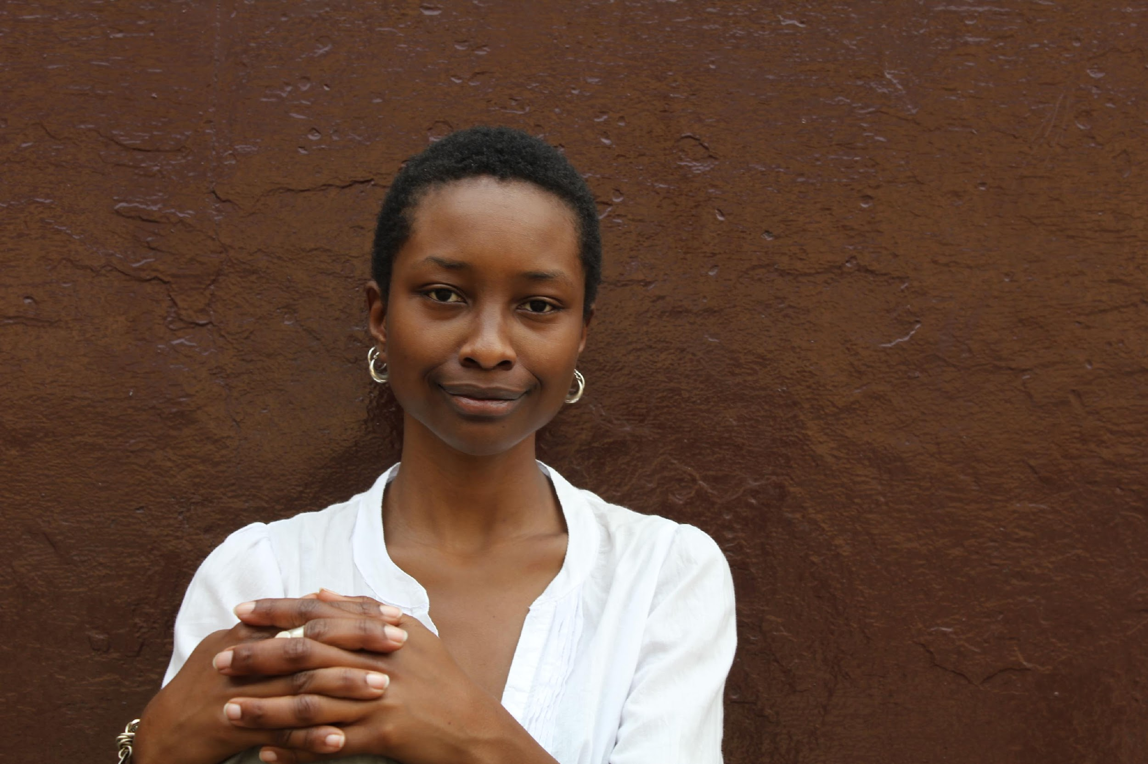
Hawa Essuman - Director
Hawa has worked in theatre and narrative storytelling for 15 years, her work ranging from TV commercials, television series' and documentary. Her feature film, Soul Boy, screened at over 40 film festivals worldwide, winning several awards, including the Dioraphte Audience Award at the International Film Festival Rotterdam. Her film premiered at the Tate Modern in 2012 as part of Olafur Eliasson's Little Sun Project.

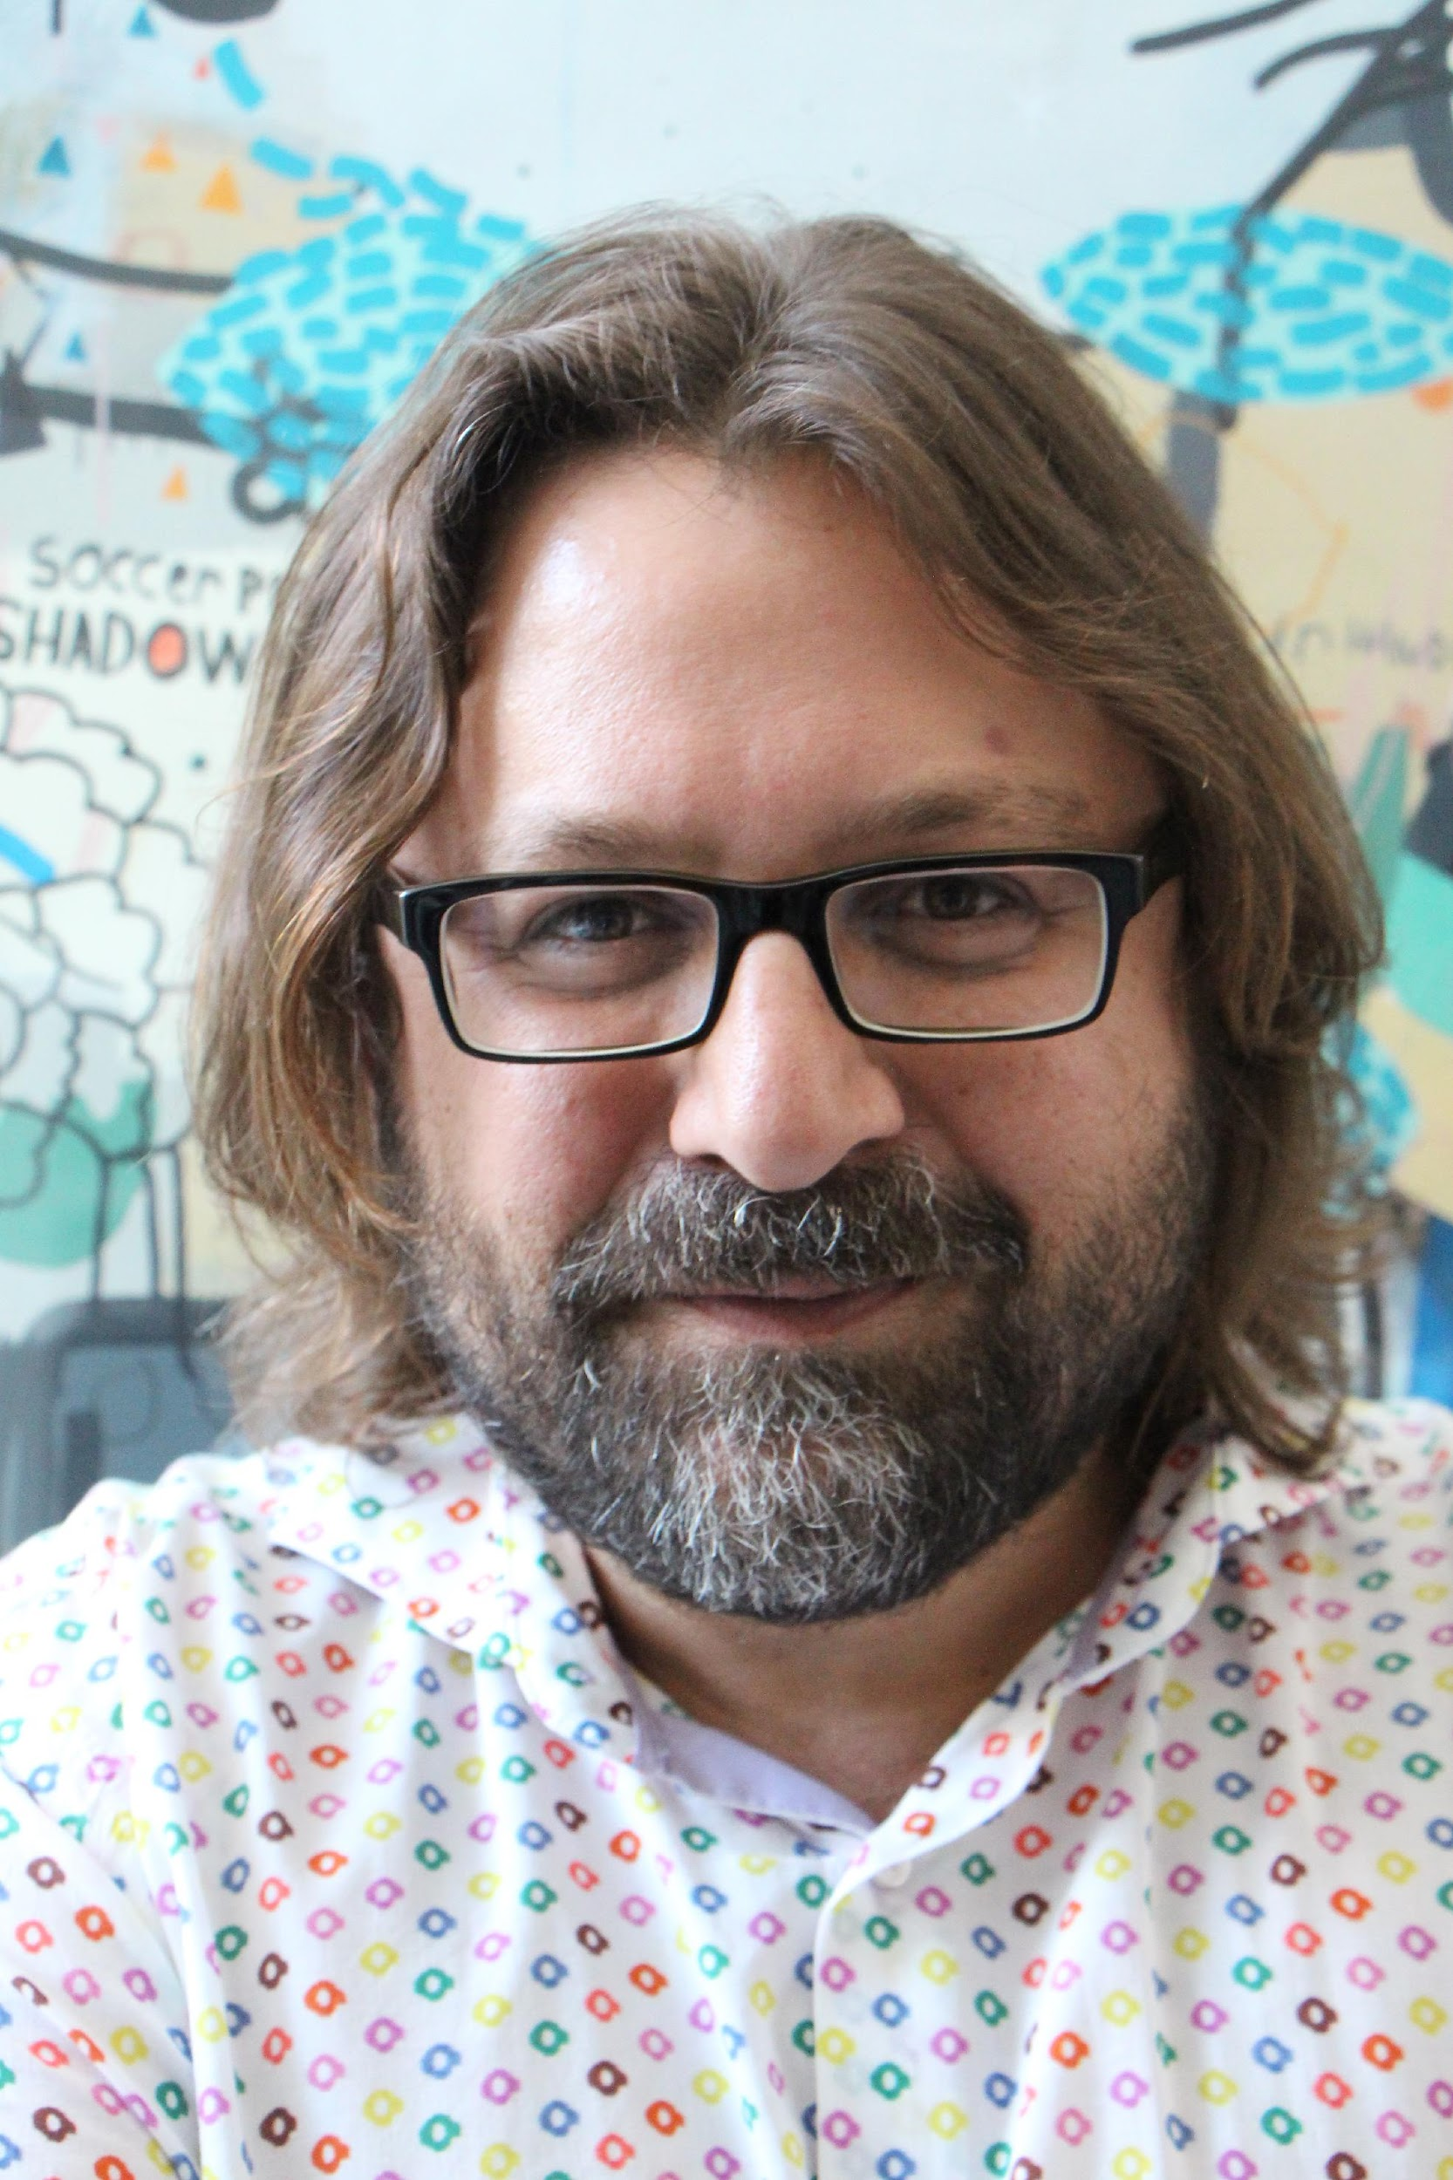
Steven Markovitz – Producer
Steven Markovitz (producer) has been producing and distributing documentaries and fiction for over 20 years. He has produced and co-produced over 50 documentaries including Winnie (Best Director World Documentary Competition Sundance 2017), Beats of the Antonov (Winner Documentary Audience Award at TIFF, 2014), One Day After Peace by Erez Laufer (Hotdocs, IDFA), Congo in Four Acts (Berlinale, Hotdocs, IDFA) and Project 10 (Sundance, Hotdocs, Berlinale, Tribeca, IDFA). Current projects include a new Yoav Shamir documentary (Defamation, Checkpoint). His fiction work has screened at Cannes, Berlinale, Toronto and Sundance, and has an Oscar nomination. He is a founder of the Encounters Documentary Festival, Electric South and has spearheaded African wide theatrical distribution. More at bigworldcinema.com

Edward Zwick – Executive Producer
Edward Zwick (executive producer) is an American filmmaker and film producer noted for his films about social and racial issues. His films include Glory (1989), Legends of the Fall (1994), The Siege (1998), The Last Samurai (2003), Blood Diamond (2006), and Defiance (2008). Along with Marshall Herskovitz, Zwick runs a film production company called The Bedford Falls Company (inspired by the name of the town featured in Frank Capra's It's A Wonderful Life). This company has produced such notable films as Traffic and Shakespeare in Love and the TV shows Thirtysomething, Relativity, Once and Again, and My So-Called Life. He was one of the recipients of the Academy Award for Best Picture for Shakespeare in Love; he was also nominated in the same category for Traffic.

Jonathan Stack - Executive Producer
Born in New York City, Jonathan spent much of his 20’s exploring the world during which time he took an interest to film.

Jonathan Stack is an Emmy Award winning and two- time Academy Award nominated documentary filmmaker. In 1991 he founded GABRIEL FILMS and has since gone on to produce over fifty films for dozens of cable channels in the US and many television partners abroad. He has released several films theatrically and shown his work at many of the major festivals including Sundance where he won the Grand Jury Prize in 1998.

While working as an independent filmmaker Stack has earned a reputation for his unique ability to gain access into forbidden and even dangerous worlds. His exclusives include, President Charles Taylor’s farewell speech to the nation of Liberia and a rare interview with David Miscaivage, head of the Church of Scientology. He has filmed inside Angola Prison over 15 years, travelled with militias in Guinea and Liberia and been to a last supper four times. He has filmed 10,000 feet below sea level and 20,000 feet above, told a few stories that took place thousands of years ago and even more stories that are happening today.

He founded World Vasectomy Day with Dr. Doug Stein to inspire men world wide to part of the most important decision of our lives.

Credits

Cinephil presents ‘SILAS’
An Ink & Pepper Big World Cinema Production
Produced with the participation of Blue Ice Docs
In association with Gabriel Films

Made with the support of
JustFilms | Ford Foundation
John D. and Catherine T. MacArthur Foundation
Sundance Institute Documentary Film Program
with support from
Open Society Foundations
Ford Foundation | JustFilms
The Kendeda Fund
Stories of Change, a project of Sundance Institute supported by the Skoll Foundation
IDFA Bertha Fund
Hot Docs–Blue Ice Group Documentary Fund
The PUMA.Creative Catalyst Award in Partnership with Channel 4 BRITDOC Foundation
The Alter-Ciné Foundation

Story Consultants Joelle Alexis, Iikka Vehkalahti
Music by Brendan Canning, Ohad Benchetrit
Co-Executive Producers Steven Silver, Neil Tabatznik and Robin Smith
Executive Producers Leonardo DiCaprio, One other ,Edward Zwick, Jonathan Stack
Co-Producer Tamsin Ranger
Edited by Andrew MacCormack, Roderick Deogrades
Cinematography by Joan Poggio, Anjali Nayar
Written by Anjali Nayar
Produced by Steven Markovitz Anjali Nayar
Directed by Anjali Nayar Hawa Essuman

TIFF Screenings:

Press & Industry 1 | 09/10/17 | 4:30PM | Scotiabank 8
Public 1 | 09/11/17 | 7:15PM | Scotiabank 10
Public 2 | 09/13/17 | 11:30AM | TIFF Bell Lightbox Cinema 3
Press & Industry 2 | 09/14/17 | 12:00PM | Scotiabank 7
Public 3 | 09/16/17 | 6:30PM | Scotiabank 14

For more information: https://www.silasthemovie.com/

