# 

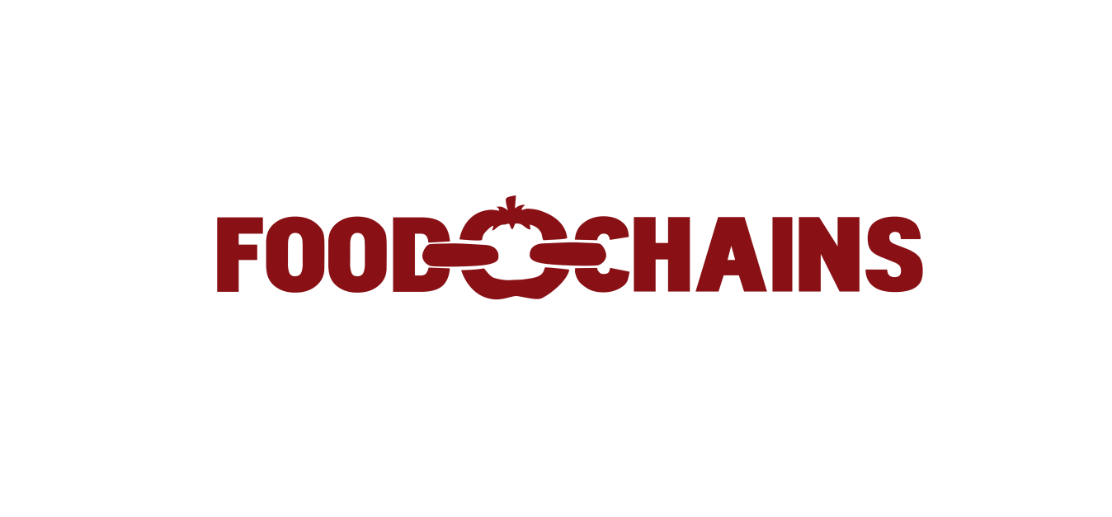





# Official Selection:: Berlinale 2014 :: Culinary Cinema Programme Official Selection:: Tribeca 2014 :: Tribeca Talks Series

## Press Kit

**Director:** Sanjay Rawal  
**Producers**: Smriti Keshari, Sanjay Rawal, Eva Longoria Hamilton Fish  
**Exec. Producers**: Eva Longoria, Eric Schlosser, Lekha Singh, Abigail Disney, David Damian Figueroa, Bob Leary, Alfonso Montiel, Roberto Gonzalez Barrera, Alisa Swidler, Mayra Hernandez  
**Participants**: The Coalition of Immokalee Workers, Dolores Huerta, Eric Schlosser, Eva Longoria, Barry Estabrook, Kerry Kennedy, Robert F. Kennedy Jr.  
**Editors**: Erin Barnett, Emily Clifton  
**Language**: English  
**Runtime**: 82 minutes (TBD)  
**Production Land**: United States, 2014  
**Production Companies**: Illumine Films and Two Moons Productions  
**Sales Agent**: Visit Films :: Aida LiPera :: [aida@visitfilms.com](mailto:aida@visitfilms.com)  
**North Am Distributor:** Screen Media

# Logline

In this exposé, an intrepid group of workers battle to defeat the $4 trillion global supermarket industry, revealing the rampant abuse of farm laborers in the United States.

# Synopsis

There is more interest in food these days than ever, yet there is very little interest in the hands that pick it. Farmworkers who form the foundation of our fresh food industry are routinely abused and robbed of wages. In extreme cases they can be beaten, sexually harassed or even enslaved – all within the borders of the United States.

Food Chains exposes the human cost in our food supply and the complicity of the supermarket industry. Supermarkets earn $4 trillion globally and have tremendous power over the agricultural system. Over the past 3 decades they have drained revenue from their supply chain leaving farmworkers in poverty and forced to work under subhuman conditions. Yet supermarkets take no responsibility for this.

The narrative of the film focuses on an intrepid and highly lauded group of tomato pickers from Southern Florida – the Coalition of Immokalee Workers or CIW - who are revolutionizing farm labor.

The film begins in Immokalee, Florida, one of the poorest towns in America yet at the same time, is the heart of the multibillion dollar tomato industry. Workers toil in the fields, picking more than four thousands pounds of tomatoes a day for barely the minimum wage.

Agriculture remains the backbone of America, generating billions of dollars of revenue for those atop the food chain. Those at the bottom, however, see very little of those profits. Farmworkers remain desperately poor, averaging about $12,000 per year in wages.

The CIW is protesting Publix, Florida’s largest supermarket chains and one of the largest in the world. These workers don’t have millions of dollars to advertise. They just have their bodies and are launching a hunger strike on the lawn of Publix’s headquarters. The irony of farmworkers starving themselves at a grocery corporation’s offices is lost on Publix who refuse to meet the CIW.

The CIW are asking Publix to pay just a penny more per pound for the tomatoes they buy, which would double farmworker wages. Moreover, the CIW wants Publix to exert its incredible market power over its supply chain and force farmers to treat workers with dignity and respect.

Over the six-day hunger strike, we learn about the massive power of the supermarket industry and how it is perpetuating an issue that has plagued the United States for centuries.

The film carries a powerful call to action for every viewer to demand that retailers use their power to eradicate abuse in their supply chains. The film is one of hope and promise for the triumph of morality over corporate greed - to ensure a dignified life for farm workers and a more humane, transparent food chain.

# The Issues

Globally, agriculture generates billions of dollars of revenue for those atop the food chain. Farmworkers at the base remain desperately poor, however, averaging about $12,000 per year in wages in the United States. Estimates for wages in other countries, including those in Europe, are even lower.

In such dire poverty, workers have little to no recourse if they lose their jobs. Therefore, many are willing to accept exploitation that most other workers in the US and Europe wouldn’t. This desperation has always existed in farm labor, though, and as a result, the industry to continues to draw supervisors from time to time whose treatment of workers can be shocking.

Federal and state enforcement of farm labor has always been scant, if not nonexistent – in both the US and abroad. The state of Florida has 14 labor inspectors to protect the rights of 100,000 workers. This coupled with the general geographic isolation of fields leads to a workplace of exploitation.

 In this environment, farmworkers can routinely face verbal abuse, physical abuse and sexual harassment. One in four American women experience some sort of harassment in the workplace. With female farmworkers, this number is estimated in upwards of four in five.

A combination of low wages, poor housing, and lack of communication with law enforcement and labor inspectors can lead to the worst types of exploitation, ones unimaginable in any modern nation much less the United States. The NGO Free the Slaves estimates that upwards of 10,000 farmworkers live in conditions of modern-day slavery in the US – under threat of physical abuse or death if they were to try to leave their jobs. These workers receive no pay, are sometimes shackled at night and often suffer severe psychological damage.

The exploitation of workers is not an immigration issue in the US. Hundreds of US-born farmworkers have been freed from modern-day slavery in the last 10 years. Exploitation has always existed in farm work and is a factor of low wages, not simply immigration status.

 As the CIW have proven, raise wages and enforce laws and exploitation will end. Their model is unique in its use market (economic) consequences driving good behavior rather than fear of state or federal penalties (which are, again, rarely enforced, if at all).

While the CIW has had much success, the largest of the food purchasers in the U.S., supermarkets, have still not signed onto the Fair Food Program. Their purchasing power contributes to the stagnant wages and human rights abuses in the fields.

We have to change this. The CIW’s model is one that farmworkers can replicate globally. In fact, it’s a model for low-wage workers in all industries.

# Director’s Statement: Sanjay Rawal

Reflecting on the experience of my first feature film, I cannot claim to have brought anything profound to the process. In fact, making this film was at times overwhelmingly challenging. We had to spend months building the trust of subjects; we had to sneak onto farms to get footage; and we had to fight corporations every step of the way – frankly nothing out-of-the-ordinary for an exposé film.

In a strange way, however, on a personal level the film was the bridge between the past and the present. My father, for example, spent more than half his life in the tomato industry and though I thought I uncovered the narrative of the film by chance, it was informed uniquely by my past.

The idea for *Food Chains* was inspired after I departed from a tomato conference that I was attending in place of my father. On a long drive through central Florida as farm after farm flickered past my window hugging swampland that carried the memories of hundreds of thousands of slaves, poor Black sharecroppers and now of exploited migrant Mexican farmworkers, the human cost in our food system was revealed.

Eighteen-wheelers with tens of thousands of dollars of tomatoes piled into uncovered trailers rumbled past rickety buses of sweaty, tired tomato pickers. In an era where there’s more interest in food than ever before, I asked myself why there is such little interest in the hands that pick that food?

We base the main narrative of our film on the work of the Coalition of Immokalee Workers (CIW), an intrepid group of tomato pickers from Florida that had battled the largest buyers of tomatoes in the world – multibillion dollar retailers like McDonald’s and Trader Joes – and had convinced them to address both the poverty and exploitation of farmworkers in their supply chain.

Their battle encompasses the rising threat of inequality, unfair wages and a nonexistent immigration policy on the fabric of American life and something we were humbled to be able to document.

***Sanjay Rawal***

# About the Filmmakers

## Sanjay Rawal, Director, Producer

Sanjay spent over a decade working in the agricultural, non-profit and government sectors globally while running a genetics company with his father, Dr. Kanti Rawal. After working with Abby Disney and Gini Reticker on their documentary Pray the Devil Back to Hell (2008), he was bit by the film bug. His first short, Ocean Monk (2010), took the Best Short Doc Prize (online) at the 2010 St. Louis Film Festival. His second film, Challenging Impossibility (2011), premiered at the Tribeca Film Festival and played in 75 more, winning a number of awards.

## Smriti Keshari, Producer

Smriti is a personable film producer, shooter and storyteller with a focus on complex systems and human behavior. She has a roster of projects which have explored lands, stories or issues not heavily reported. She has an eye for choosing narratives that offer underrepresented perspectives and inspire social action. She has produced several short documentaries as well as a recently acquired television series, Surfing 28 States: India, which follows two Australian travelers through India as they explore the country and volunteer with local charities. She has also contributed to ESPN original content (ESPN Films, X Games, E:60) and has had her photography showcased in a number of publications.

## Eva Longoria, Executive Producer, Producer

Eva is best known for her role on the hit series Desperate Housewives and is also a noted activist on Hispanic issues. She has been honored with numerous awards for her achievements, including “Philanthropist of the Year,” “Latina Visionary and Community Empowerment Award” and the “Cesar Chavez Legacy Award.” Her last documentary in collaboration with Academy Award nominated Shine Global, The Harvest, on child farm workers, won a number of awards at film festivals.

## Eric Schlosser, Executive Producer

A renowned labor activist, author (Fast Food Nation) and filmmaker (Food Inc.), Eric appeared in The Nation Magazine’s food issue in 2011, writing “I hope that the food movement will continue to grow and thrive. More important, I hope that it will become part of a larger movement with a broader vision—a movement committed to opposing unchecked corporate power, to gaining a living wage and a safe workplace and good health for the millions of Americans who lack them.”

## Hamilton Fish, Producer

Hamilton is a champion of social justice whose accomplishments include the reinvigoration of the Nation magazine making it the exemplary journal of politics and protest that it is today. He is also an accomplished filmmaker, having produced The Memory of Justice and the Academy Award-winning documentary Hotel Terminus.

## Forest Woodward, Director of Photography

Forest is an acclaimed professional photographer (2011 PDN) whose photos regularly appear in various publications (National Geographic, Forbes, Patagonia, Daily Beast). Forest brings a photographer’s perspective to filmmaking and his cinematography has appeared in various commercials (ESPN, Coachella), short films and feature length documentaries.

## Alison Ellwood, Consulting Producer

Alison is a highly sought-after director and editor whose films have won numerous accolades (editor: Casino Jack, Enron, Gonzo; director: The Eagles, Magic Trip). A long-time collaborator of Oscar-Winner Alex Gibney, Alison’s films have pushed the edge of storytelling and socio-political expose.

## Erin Barnett, Editor

Erin is a dynamic and insightful editor who honed her craft at Alex Gibney’s Jigsaw Productions. Erin’s credits include the Oscar-nominated Mea Maxima Culpa and the award-winning films Client 9 and Park Avenue.

# Food Chains Film Excerpts

I still believe agriculture is the backbone of America and when you have an industry as big as agriculture you have to pay attention to the labor force. People often look at farmworker issues as an immigration issue but it’s more than an immigration issue, it’s a human rights issue.

-Eva Longoria, Actress & Farmworker Advocate

There's probably never been as much interest in food as there is right now. So many people are learning how to cook. And so many people are fascinated by different ingredients and different combinations of ingredients, and that's wonderful. But people need to take the next step and be concerned about the human beings who bring us those ingredients. So a more holistic view of this food movement would have a concern for the land, would have a concern for sustainability, would have a concern for animal welfare, but would fundamentally have a concern for human beings and what this system is doing to them.

-Eric Schlosser, author of *Fast Food Nation*

I think it would be easy to demonize farmers and say it’s these terrible farmers who are to blame and hold them responsible for the poor wages of migrants. That might have been true in some cases thirty years ago, forty years ago but that’s not really the problem today. You’ve got to look at where the real power in this food system is today. The real power today is with big fast food chains, big food service companies, and the huge supermarket chains. Pennies more on purchases of fresh fruits and vegetables could eliminate this problem and get rid of this misery.

-Eric Schlosser, author of *Fast Food Nation*

In this country [The United States] there is a poverty level. And by the end of the year you find you did not even make it to that poverty level. You are poor because you are making others rich. I believe it is time to change that power imbalance that exist and the irresponsibility on the corporations side which for years have only been interested in making money, money, money.

What we want is a modern industry where we no longer even have a shadow of slavery, sexual harassment, pesticide abuse, where the workers are actually respected for what they are - human beings and an important part of the economy ... and the people who put food on the table of millions of homes each day.

* Lucas Benitez, co-founder of the Coalition of Immokalee Workers (CIW)

The buyers create this pressure that makes it impossible for the industry to work in a normal way. In order to be able to produce more, you have to push the workers to work faster for less pay. They are creating the poverty of Immokalee so they have an obligation to help us eliminate this.

-Gerardo Reyes Chavez, Farmworker and CIW Member

The struggle for fundamental human rights isn’t limited simply to the fields here in the United States. Workers at the base of any of these massive supply chains that exist around the world face the same struggles that we do. In the 21st Century the responsibility for protecting worker’s rights has to be shared by the corporations who control where those workers toil. Slowly we’re seeing huge multibillion-dollar companies forced to recognize their own responsibility and change the way they do business.

-Greg Asbed, co-founder of the CIW